Batch:D2 Roll No.:16010221038

Experiment / assignment / tutorial No. 3

Grade: AA / AB / BB / BC / CC / CD /DD

Signature of the Staff In-charge with date

**Title – Projectile Motion**

CO2: Analyze the concept of kinematics of particle and rigid body.

**Objective**

To find the Time of flight, Horizontal range and maximum height of a projectile for different  velocity, angle of projection, cannon height and environment.

**Theory**

### Projectile Motion

Projectile is defined as, any body thrown with some initial velocity, which is then allowed to move under the action of gravity alone, without being propelled by any engine or fuel. The path followed by a projectile is called its trajectory. A projectile moves at a constant speed in the horizontal direction while experiencing a constant acceleration of 9.8 m/s2 downwards in the vertical direction. To be consistent, we define the up or upwards direction to be the positive direction. Therefore the acceleration of gravity is, -9.8 m/s2.

**Horizontal motion of projectile**

The speed in the horizontal direction is 'vx' and this speed doesn't change. The equation which predicts the position at any time in the horizontal direction is simply,

«math xmlns=¨http://www.w3.org/1998/Math/MathML¨»«mi»x«/mi»«mo»=«/mo»«msub»«mi»v«/mi»«mi»x«/mi»«/msub»«mi»t«/mi»«mo»§nbsp;«/mo»«mo»§nbsp;«/mo»«mo»§nbsp;«/mo»«mo»§nbsp;«/mo»«mo»§nbsp;«/mo»«mo»§nbsp;«/mo»«mo»§nbsp;«/mo»«mo»§nbsp;«/mo»«mo»§nbsp;«/mo»«mo»§nbsp;«/mo»«mo»§nbsp;«/mo»«mo»§nbsp;«/mo»«mo»§nbsp;«/mo»«mo»§nbsp;«/mo»«mo»§nbsp;«/mo»«mo»§nbsp;«/mo»«mo»§nbsp;«/mo»«/math»

**Vertical motion of projectile**

Because gravity has a downward pull, the vertical velocity changes constantly. The equation that predicts the vertical velocity at any time 'vy' is

«math xmlns=¨http://www.w3.org/1998/Math/MathML¨»«msub»«mi»v«/mi»«mi»y«/mi»«/msub»«mo»=«/mo»«msub»«mi»v«/mi»«mrow»«mi»o«/mi»«mi»y«/mi»«/mrow»«/msub»«mo»+«/mo»«mi»a«/mi»«mi»t«/mi»«mo»§nbsp;«/mo»«mo»§nbsp;«/mo»«mo»§nbsp;«/mo»«mo»§nbsp;«/mo»«mo»§nbsp;«/mo»«mo»§nbsp;«/mo»«mo»§nbsp;«/mo»«mo»§nbsp;«/mo»«mo»§nbsp;«/mo»«mo»§nbsp;«/mo»«mo»§nbsp;«/mo»«mo»§nbsp;«/mo»«mo»§nbsp;«/mo»«mo»§nbsp;«/mo»«/math»

The 'Voy' is simply the original velocity in the vertical or y-direction.  
To calculate the position in the y-direction, the full distance formula must be used. 'Yo', represents the original position in the y-direction.

«math xmlns=¨http://www.w3.org/1998/Math/MathML¨»«msub»«mi»y«/mi»«mi»f«/mi»«/msub»«mo»=«/mo»«msub»«mi»y«/mi»«mi»o«/mi»«/msub»«mo»+«/mo»«msub»«mi»v«/mi»«mrow»«mi»o«/mi»«mi»y«/mi»«/mrow»«/msub»«mi»t«/mi»«mo»+«/mo»«mfrac»«mn»1«/mn»«mn»2«/mn»«/mfrac»«mi»a«/mi»«msup»«mi»t«/mi»«mn»2«/mn»«/msup»«/math»

Acceleration for projectiles near the Earth's surface is -9.8 m/s2. We don't re-write the equation with a negative sign.  Rather, we use the negative acceleration value when solving problems.  
   
When a projectile is launched horizontally  a ball rolls off a table, a car runs off the edge of a cliff, etc.  Here the original y-velocity is zero. For example, if the projectile drops 10 meters, you can set the Yo = 0 and Yf = -10 m. Or, you can set Yo = 10 m and Yf = 0. Either works out the same.

**Velocity**

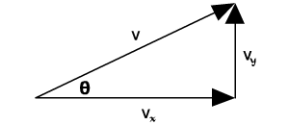To determine the total velocity of a projectile, we combine the horizontal velocity  
('vx') and the vertical velocity ('vy') using the Pythagorean Theorem,

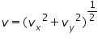

**At maximum height**

At the top of its path, the projectile no longer is going up and hasn't started down, yet. Its vertical velocity is zero ( vy = 0 ). The only velocity it has is just its horizontal velocity, vx. Remember, the horizontal speed stays constant throughout the projectile path.

A common misconception occurs at the top of a projectile's arc. When asked what the acceleration of the projectile is at this point, many people answer "zero". If it were zero, the projectile would simply keep going in a straight line. However, gravity is still acting, pulling it down, and accelerating it towards the earth. Thus the acceleration at the top is still -9.8 m/s2, just as it's been all along.

**Range of projectile motion**

For a projectile that is launched at an angle and returns to the same height, we can determine the range or distance it goes horizontally using a fairly simple equation.

* When the projectile is launched at a steep angle, it spends more time in the air than it does when launched at a shallow angle.
* When the projectile is launched at a shallow angle, it goes faster in the horizontal direction than if it is launched at a steep angle.

The ideal combination of time in the air and horizontal speed occurs at 45o. Thus the maximum range or distance occurs when the projectile is launched at this angle. This applies to long jumpers and soccer balls that are two good examples. However, if the projectile starts at a point higher than where it lands, the ideal distance doesn't occur at a 45o angle. Ask your instructor for an explanation. If you calculate the range for a projectile launched at 30o, you will find it's the same as a projectile launched at 60o. The same goes for 40o and 50o. The graph of range vs angle is symmetrical around the 45o maximum.

The equations used to find out various parameters are shown below;

Time of flight, «math xmlns=¨http://www.w3.org/1998/Math/MathML¨»«mi»T«/mi»«mo»=«/mo»«mfrac»«mrow»«mn»2«/mn»«mi»u«/mi»«mi mathvariant=¨normal¨»sin«/mi»«mi»§#952;«/mi»«/mrow»«mi»g«/mi»«/mfrac»«/math»

Maximum height,«math xmlns=¨http://www.w3.org/1998/Math/MathML¨»«mi»H«/mi»«mo»=«/mo»«mfrac»«mrow»«msup»«mi»u«/mi»«mn»2«/mn»«/msup»«msup»«mi mathvariant=¨normal¨»sin«/mi»«mn»2«/mn»«/msup»«mi»§#952;«/mi»«/mrow»«mrow»«mn»2«/mn»«mi»g«/mi»«/mrow»«/mfrac»«/math»

Horizontal range,«math xmlns=¨http://www.w3.org/1998/Math/MathML¨»«mi»R«/mi»«mo»=«/mo»«mfrac»«mrow»«msup»«mi»u«/mi»«mn»2«/mn»«/msup»«mi mathvariant=¨normal¨»sin«/mi»«mn»2«/mn»«mi»§#952;«/mi»«/mrow»«mi»g«/mi»«/mfrac»«/math»

If the body is projecting from a height “h” above the ground level, the additional height ‘h’ is to be considered and the equations modified accordingly.

**Procedure:**

Select a type of environment from the right of the simulator. Gravity changes according to the environment. Select the velocity, angle of projection and height of the cannon from the slider respectively. After clicking the fire button the user can view the motion of the projectile and also the time of flight, maximum height and range of the projectile.

**Variable Region:**

1. The 'Choose Environment' combo box helps you to choose the type of environment that the simulation has to be performed. As the environment changes the gravity also change.
2. The 'Velocity' slider helps you to fix the velocity of the projectile.
3. The 'Angle of Projection' slider helps you to fix the angle of the projection of the projectile.

**Measurement Region:**

1. 'Time' shows the time of flight of the projectile.
2. 'Height' shows the maximum height the projectile has reached.
3. 'Range' shows the maximum distance the projectile has moved.

**Setup Diagram:**

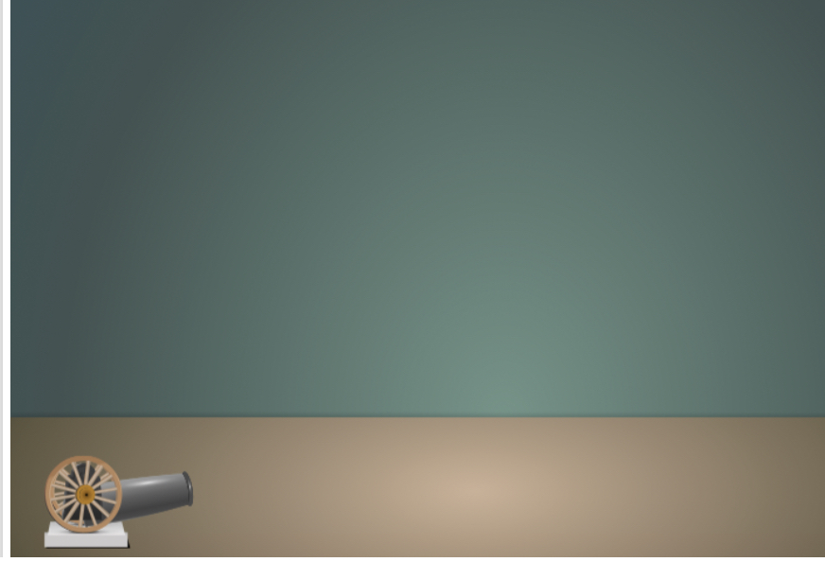

**Observation Table**

|  |  |  |  |  |  |  |  |  |  |
| --- | --- | --- | --- | --- | --- | --- | --- | --- | --- |
| **Environm**  **ent** | **g(m/s2)** | **U**  **(m/s)** | **θ** | **Analytical** | | | **Simulation** | | |
|  |  |  |  | Ta | Ha | Ra | Ts | Hs | Rs |
| Earth | 9.8 | 40 | 45 | 5.770 | 40.784 | 163.265 | 5.770 | 40.784 | 163.265 |
| Moon | 1.6 | 40 | 45 | 35.341 | 249.801 | 999.992 | 35.341 | 249.801 | 999.992 |
| Uranus | 10.67 | 40 | 45 | 5.300 | 37.458 | 149.966 | 5.300 | 37.458 | 149.966 |
| Saturn | 11.08 | 40 | 45 | 5.103 | 36.072 | 144.392 | 5.103 | 36.072 | 144.392 |
| Jupiter | 25.95 | 40 | 45 | 2.179 | 15.402 | 61.656 | 2.179 | 15.402 | 61.656 |

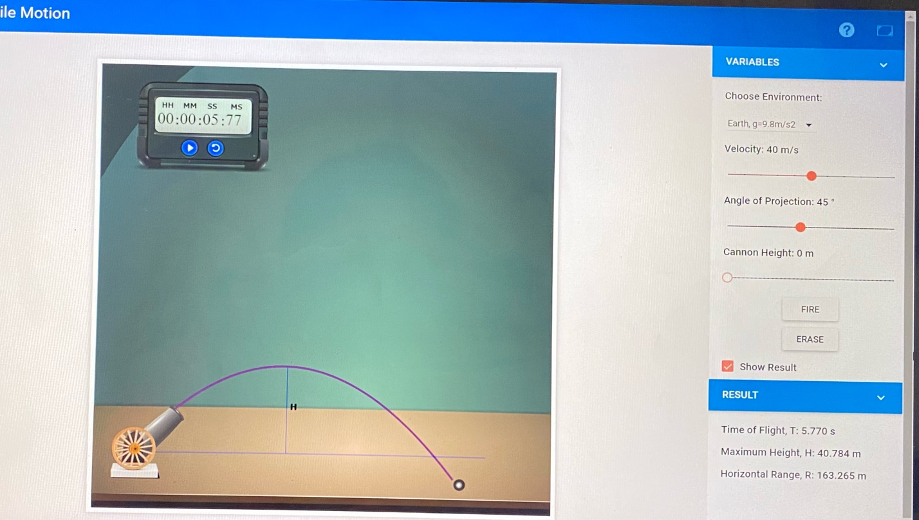**Screenshots**

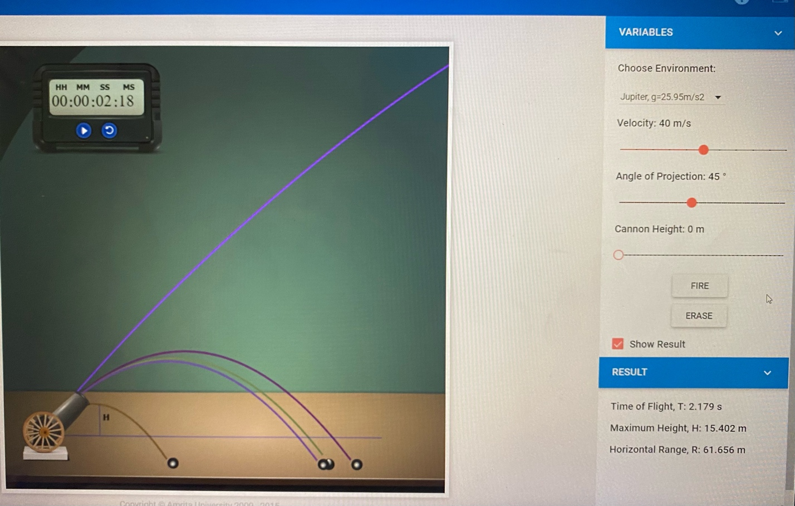

**Calculation**

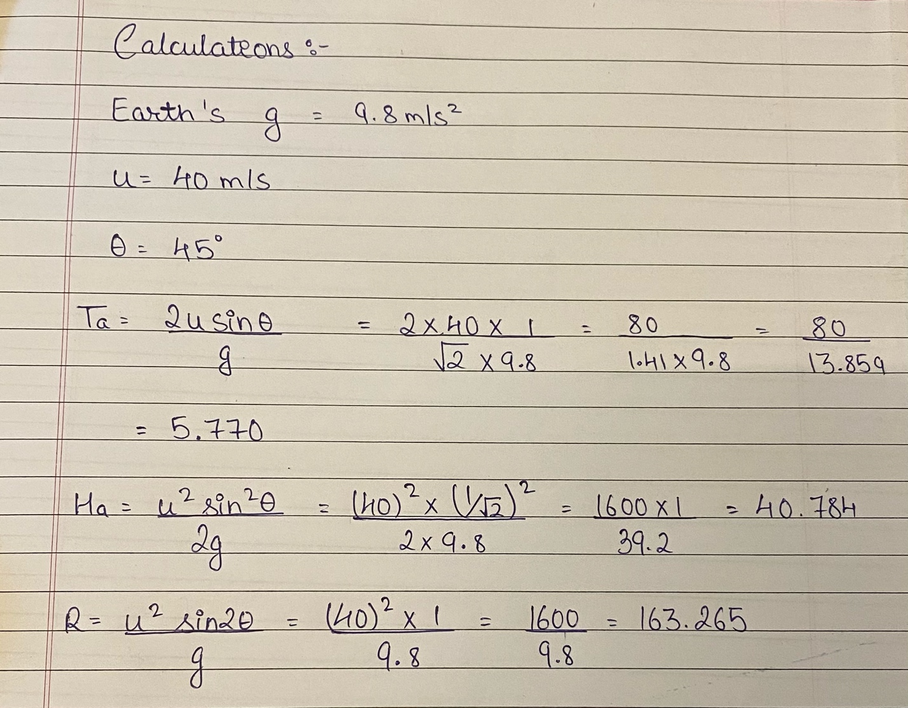

**Conclusion**

So we conclude that as acceleration due to gravity ‘g’ increases, Time of flight ‘T’, Maximum height ‘H’ and Horizontal range ‘R’ decreases.

**Signature of faculty in-charge**